

Name: Rashid zahoor
Sap id: 76816
Professor: Sayed yawar abass sb
Subject: Ict
Project: Stock control sheet for retail shop
University: Riphah international university isb
Department: BS. Cyber security _1

Contents
STOCK CONTROL SHEET FOR RETAIL SHOP 2
Abstract 2
Introduction 2
Purpose of the Project 8
Data Fields in the Sheet 9
SUM formula used 9
Sales Value Formula (recommended but missing) 9
Conclusion 9
Summary 10

STOCK CONTROL SHEET FOR RETAIL SHOP

Abstract
This project is a Stock Control Sheet designed in Microsoft Excel for managing a retail shop’s inventory. It helps track unit price, quantity in hand, quantity sold, inventory value, and sales value. The sheet uses basic Excel formulas to calculate totals and automatically update stock-related information. This project demonstrates the practical use of Excel functions for business management and inventory tracking.

Introduction
Inventory management is essential for retail businesses. Keeping track of stock levels, sales, and product values manually can be difficult and time-consuming.
This Excel-based Stock Control Sheet provides a simple and efficient way to monitor:
- Available stock
- Items sold
- Inventory value
- Sales value

Total work screen short
- 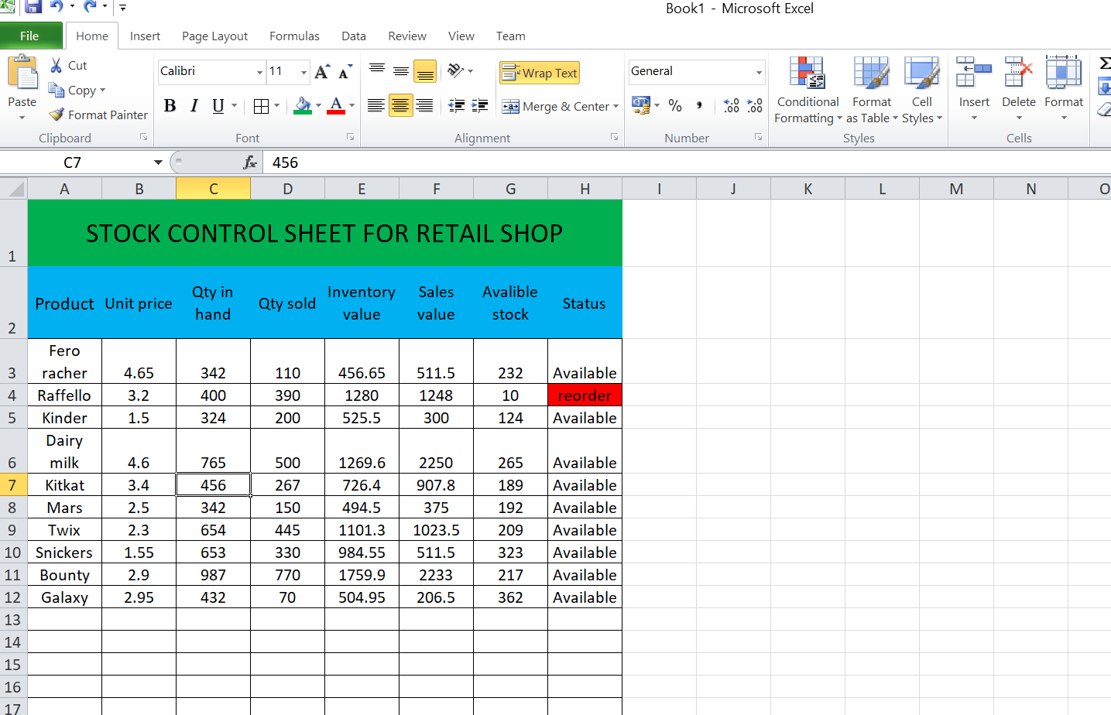
Step 1:
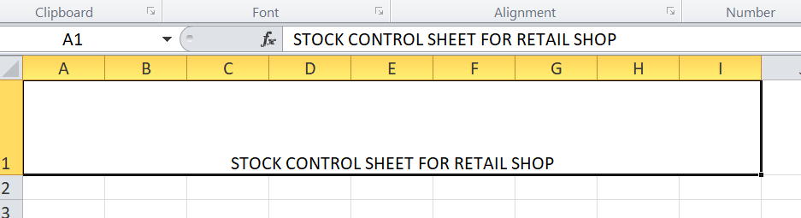

Step 2:
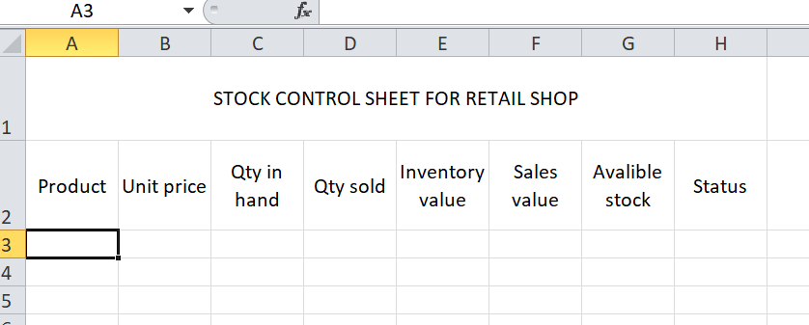
Step 3:
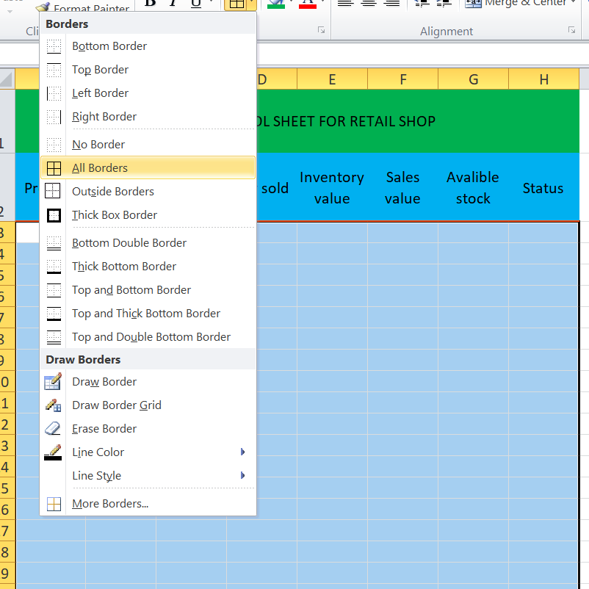
Step 4:
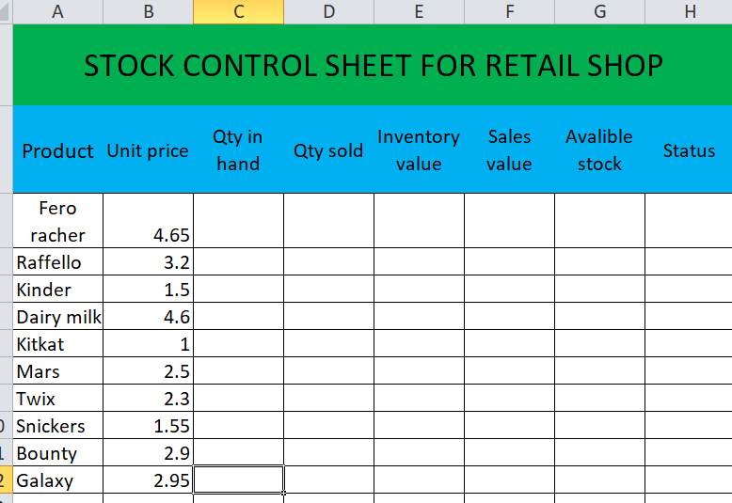
Step 5:
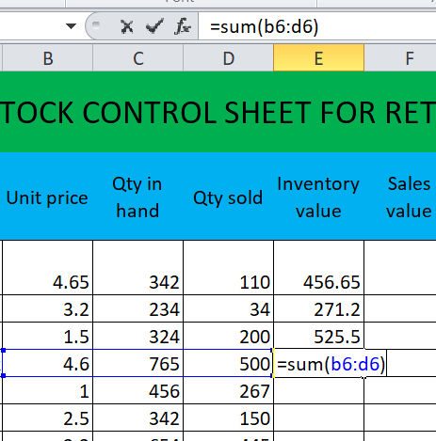
Step 6:
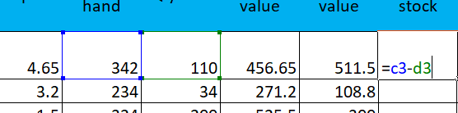
Step 7:
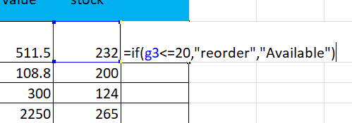

Step 8:
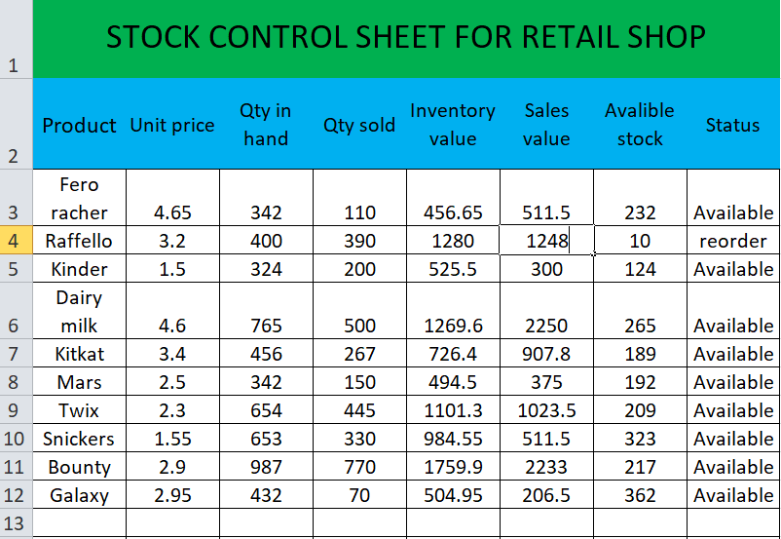

Step 9:
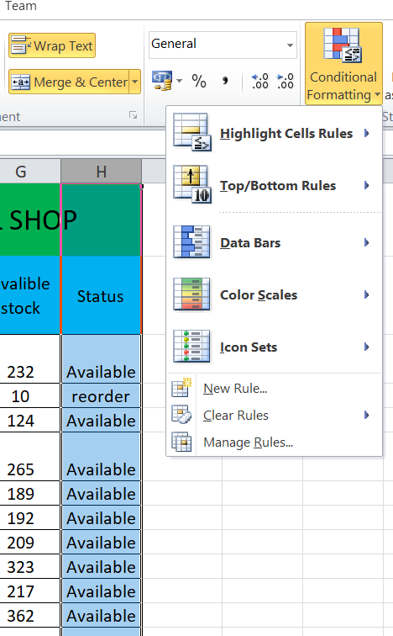
Click: conditional formatting and click new rule
Step 10:
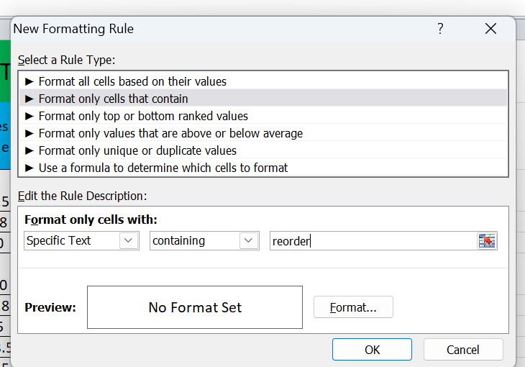
Click format only cells that contain
Step 11:
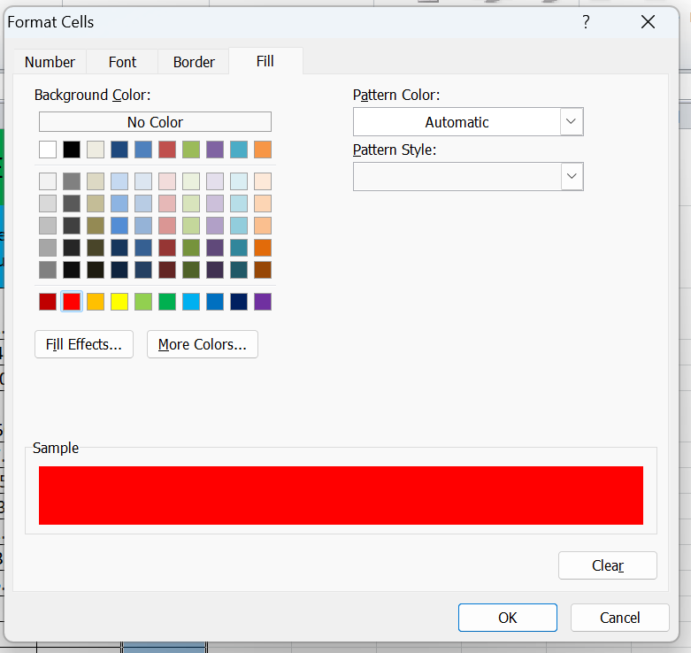

Select the colure
Step 12:
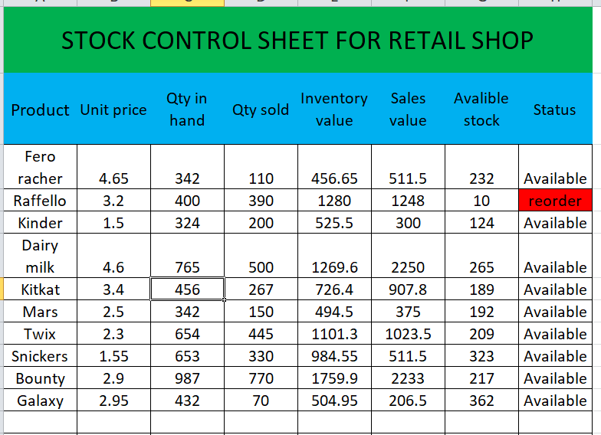
Step 13:

Purpose of the Project
The purpose of this project is:
- To maintain accurate stock records
- To calculate sales and inventory values using formulas
- To make inventory tracking easy for retail shop owners
- To provide a user-friendly Excel sheet for business management

Data Fields in the Sheet
Your stock control sheet contains the following columns:
- Unit Price
- Qty in Hand (Quantity available)
- Qty Sold
- Inventory Value
- Sales Value

SUM formula used
You used:
=SUM(B6:D6)

Sales Value Formula (recommended but missing)
(Unit Price × Qty Sold)

Conclusion
This project demonstrates how Microsoft Excel can be used for efficient retail inventory management. Using simple formulas, the sheet automates calculations that help reduce errors and save time. Though the core functionality is complete, it can be improved by adding more formulas, totals, and conditional formatting for a more professional and advanced system.

Summary
This project is a Stock Control Sheet designed in Microsoft Excel to help manage inventory for a retail shop. It keeps track of essential product information such as unit price, quantity in hand, quantity sold, inventory value, and sales value. The sheet uses Excel formulas—such as multiplication and SUM—to automatically calculate values, making the work faster and more accurate. By organizing stock data into a structured table, the sheet helps monitor available stock, determine product value, and understand sales performance. Overall, this project provides an efficient, simple, and reliable way to manage retail inventory using Excel.

